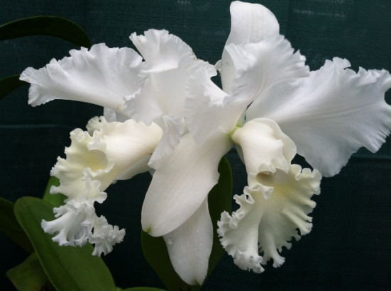
$ 2.00 Discount Coupon for Admission. www.ctorchids.org
The Annual Orchid Harvest 2014 Show and Sale
Sponsored by the Connecticut Orchid Society
Friday 10/17 from 2:00 - 5:00 Premium Shopping Day
Saturday 10/18 from 9:00 - 5:00
Sunday 10/19 from 9:00 - 4:00

At Van Wilgen’s Garden Center, 51 Valley Road (off 139), North Branford, CT

This is an AOS Sanctioned Bench Show with awards given to the best orchids

There will be beautiful orchid displays and AOS award winning orchids

Many well-known vendors with hundreds of outstanding orchids for sale

Free talks by orchid specialists on Saturday and Sunday 11:00, 12:30, 2:00

Purchase growing supplies and items to enhance your orchids, home and gardens.

Educational displays and there will be raffles throughout the day and delicious food available during the day, so make it a fun day for the family.

Admission on Saturday and Sunday $7.00
Admission on Friday for Premier Shopping Day $12.00
All weekend pass $15.00
There is a $2.00 Discount Coupon available on website www.ctorchids.org or SAVE $2.00 on Admission WITH THIS FLIER. 