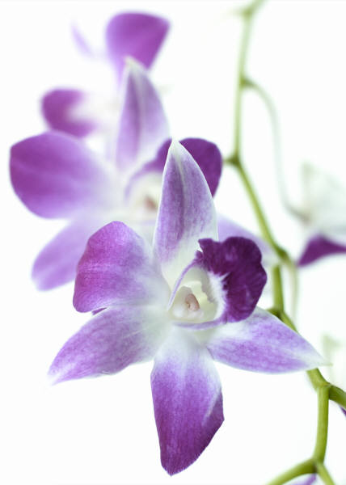ORCHID HARVEST
Presented by THE CONNECTICUT ORCHID SOCIETY

October 16-18, 2015
Shopping & Admission:
All-Weekend Pass $15.00
General Daily Admission $7.00
Free Lectures ~ Saturday & Sunday
Premier Shopping $12.00
Friday, 10/16 2pm~5pm
Photographers Free entry
Valid Saturday & Sunday, 8am – 9am only.

